The Influence of Instagram on Fast Fashion Consumption Among Youth
Sara Ahuja¹
Student, B.A. (J&MC), Semester 4,
Amity School of Communication,
Amity University Patna
+91-9430261201
thesaraahuja@gmail.com
Dr. Rahul Ahuja²
Assistant Professor,
Amity School of Communication,
Amity University Patna
+91-9709998179
therahulahuja@gmail.com
Abstract
In recent years, social media has become a powerful force in shaping consumer habits, particularly among young people. Among these platforms, Instagram stands out for its strong visual appeal and wide influence on lifestyle and fashion choices. Instagram has grown from a basic photo-sharing app into a powerful marketing platform used by businesses of all kinds. With over a billion active users worldwide, the platform offers brands a unique opportunity to connect with their audience through engaging visual content, stories, and influencer collaborations. Fast fashion known for its quickly changing styles, low prices, and trendy designs has grown rapidly thanks to Instagram. The platform’s focus on pictures and videos, along with its large number of users and smart algorithms, makes it a strong tool for spreading fashion trends and encouraging young users to buy the latest styles. This study explores the influence of Instagram on fast fashion consumption among young adults aged 16–24, examining how the platform’s visual culture, influencer marketing, and algorithmic content curation drive purchasing decisions. The research explores how visual content, influencer marketing, and trend culture on Instagram affect purchasing decisions, brand preferences, and attitudes toward fashion sustainability. The primary data for this research was collected through an online survey distributed among university students and young professionals.
Keywords: Instagram, Social Media Marketing, Fashion, Youth, Influencer Marketing
Introduction
In recent years, social media platforms have become central to the daily lives of young people, shaping their lifestyles, beliefs, and consumption patterns. Among these platforms, Instagram stands out due to its highly visual nature and widespread popularity among youth. With over a billion active users globally, Instagram offers an endless stream of fashion-related content, from influencers and brands to peer-shared outfit inspirations.
Instagram has given rise to a new consumer culture, particularly in the domain of fast fashion, characterized by inexpensive, trendy clothing that moves quickly from the catwalk to stores to meet consumer demand.
Fast fashion brands have capitalized on Instagram's potential by collaborating with influencers, launching targeted ad campaigns, and showcasing short-lived trends. This rapid exposure can influence users' buying decisions, often prompting impulse purchases and fostering a cycle of continuous consumption.
While Instagram enhances fashion accessibility and creativity, it also raises concerns about consumerism, sustainability, and the psychological pressures associated with constantly keeping up with trends.
This research investigates how Instagram influences the fast fashion consumption behavior of youth, examining the role of influencers, targeted advertisements, peer pressure, and the platform's overall design in shaping consumer habits.
Literature Review
Several studies have explored the relation between social media and consumer behavior, with Instagram emerging as a focal point in fashion marketing.
Platforms like Instagram have shifted the power dynamics in marketing, allowing consumers to become both the audience and the promoters of content. Kaplan and Haenlein (2010) describe social media as platforms that enable the creation and exchange of user-generated content, creating a two-way communication channel between brands and consumers.
Studies by Djafarova and Rushworth (2017) found that Instagram influencers play a crucial role in shaping followers' opinions and purchase intentions, especially in fashion. It found that young female consumers are highly influenced by fashion and beauty influencers, perceiving their recommendations as more authentic than traditional advertisements.
Research by Phua et al. (2017) suggests that Instagram's visual nature allows brands to engage with customers more intimately than traditional advertising methods. Influencer marketing, hashtag trends, and user-generated content all contribute to brand visibility and desirability.
Instagram facilitates identity construction, where users post curated content to receive validation in the form of likes and comments. Tiggemann and Zaccardo (2015) explore how exposure to idealized images on Instagram leads to appearance comparison and body dissatisfaction, indirectly influencing fashion choices.
In a study, Joy et al. (2012) refers Fast fashion to the rapid production of inexpensive clothing that mimics current runway trends. It is characterized by speed, affordability, disposability, and trend alignment. Brands like H&M, Zara, and Shein have capitalized on this model, appealing especially to youth who are more trend-sensitive and price-conscious.
The same study argues that fast fashion fulfills the social and psychological needs of young consumers who seek self-expression through clothing. However, it also promotes a culture of excessive consumption, often driven by social comparison and fear of missing out (FOMO), which are amplified by platforms like Instagram.
Objectives of the Study
- To study how Instagram’s platform design and content (e.g., Posts, Reels and Stories) contribute to the consumption of fast fashion among youth.
- To examine the effect of Instagram influencers, targeted advertisements, peer pressure and social validation on Instagram in promoting fast fashion consumption.
- To understand young consumer’s purchase behavior, frequency, and spending pattern on fashion purchases.
Research Methodology
This study is based on quantitative research design to examine the relationship between Instagram usage and fast fashion consumption among youth. Primary data was collected using a structured Google Form questionnaire circulated among young Instagram users aged 16–24 residing in Patna, Bihar.
Data Analysis & Interpretation
AGE
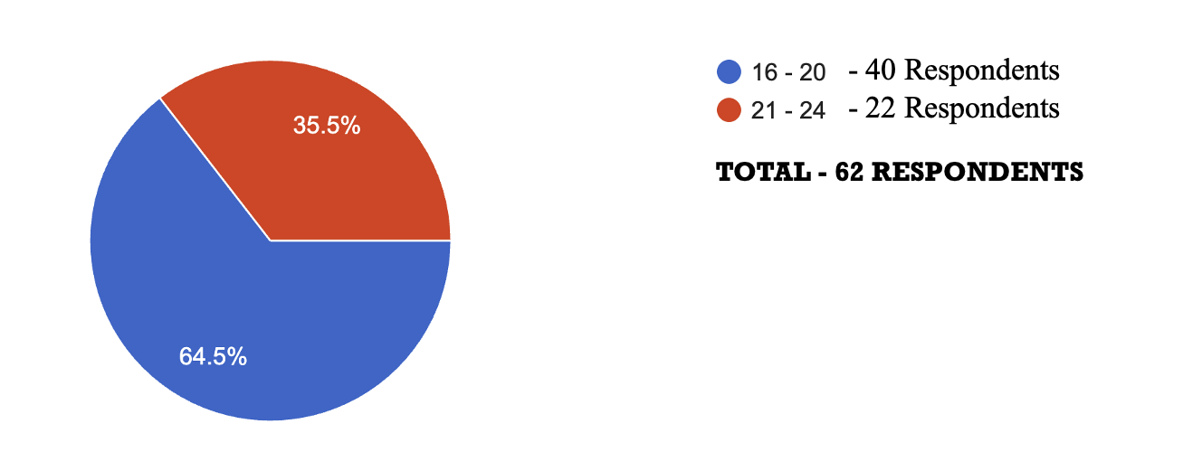
A majority of the respondents, accounting for 64.5% (40 individuals), belong to the 16–20 age group, while the remaining 35.5% (22 individuals) fall within the 21–24 age bracket.
GENDER
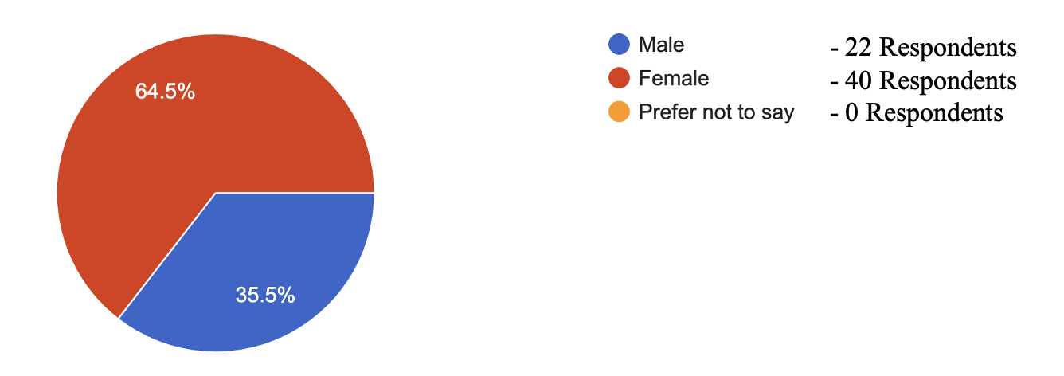
Out of the total participants, 40 respondents (64.5%) identified as female, while 22 respondents (35.5%) identified as male. Notably, there were no respondents who selected the option "Prefer not to say."
CURRENT EDUCATION LEVEL
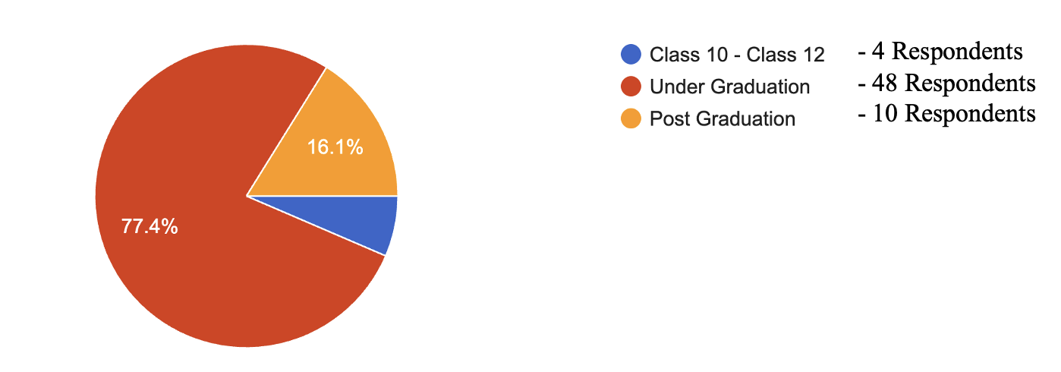
A majority, 48 respondents (77.4%), are currently pursuing their undergraduate studies. This is followed by 10 respondents (16.1%) who are enrolled in postgraduate programs, and a small fraction, 4 respondents (6.5%), who are in the Class 10 to Class 12 level.
TIME SPENT ON INSTAGRAM
How many hours per day do you spend on Instagram?
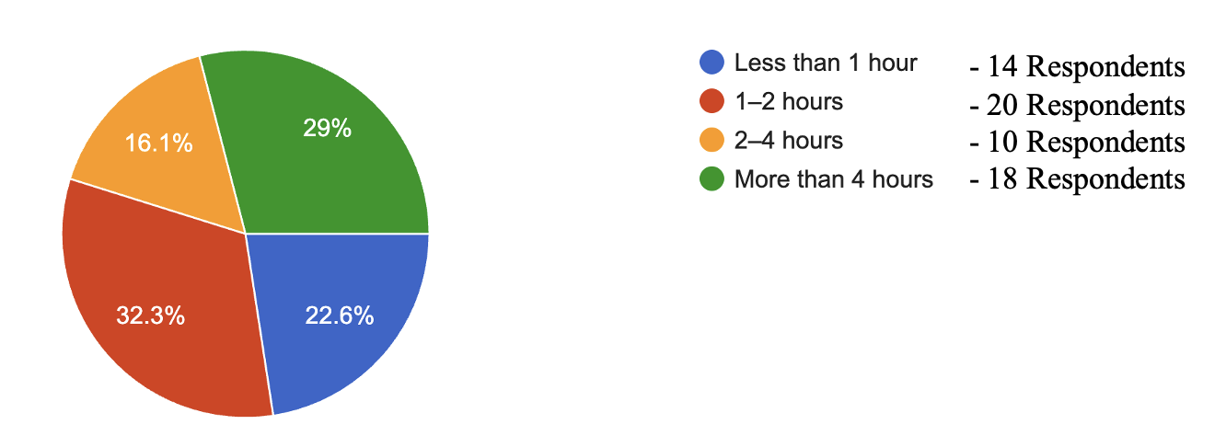
According to the survey, 22.6% of people reported that they spend less than 1 hour per day on Instagram. A larger group, 32.3%, said they use the platform for 1 to 2 hours daily. Meanwhile, 16.1% of respondents spend 2 to 4 hours on Instagram each day. Interestingly, a significant portion—29%—admitted to spending more than 4 hours on the app every day.
FOLLOWING FASHION INFLUENCERS AND BRANDS
Do you follow fashion influencers or brands on Instagram?
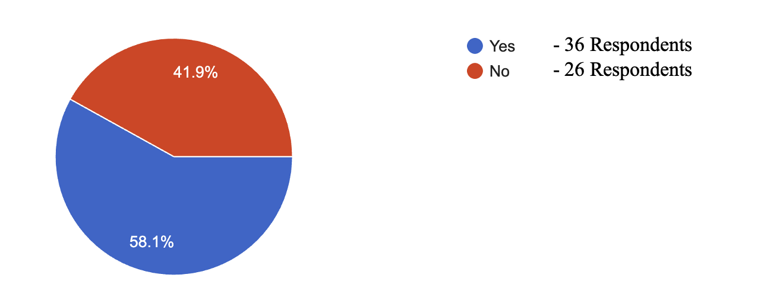
When asked whether they follow fashion influencers or brands on Instagram, 49.1% of respondents said yes, showing a strong interest in fashion-related content. However, a slightly larger portion, 58.1%, stated that they do not follow fashion influencers or brands, indicating that not everyone turns to Instagram for style inspiration.
COMING ACROSS FASHION RELATED CONTENT
How often do you come across fashion-related content on Instagram?
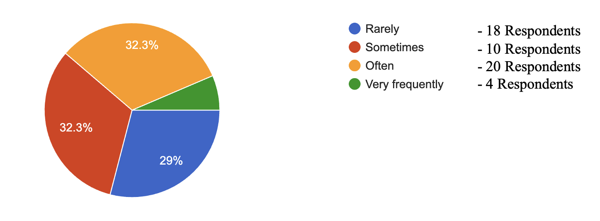
When asked how often they come across fashion-related content on Instagram, 29% of users said they rarely see such posts. Meanwhile, 32.3% of respondents mentioned that they come across fashion content sometimes, and an equal 32.3% said they see it often. The remaining percentage of users said they encounter fashion-related content very frequently, indicating a strong presence of fashion in many people's Instagram feeds.
INSTAGRAM INFLUENCING PURCHASE
Have you ever bought clothing or accessories because you saw them on Instagram?
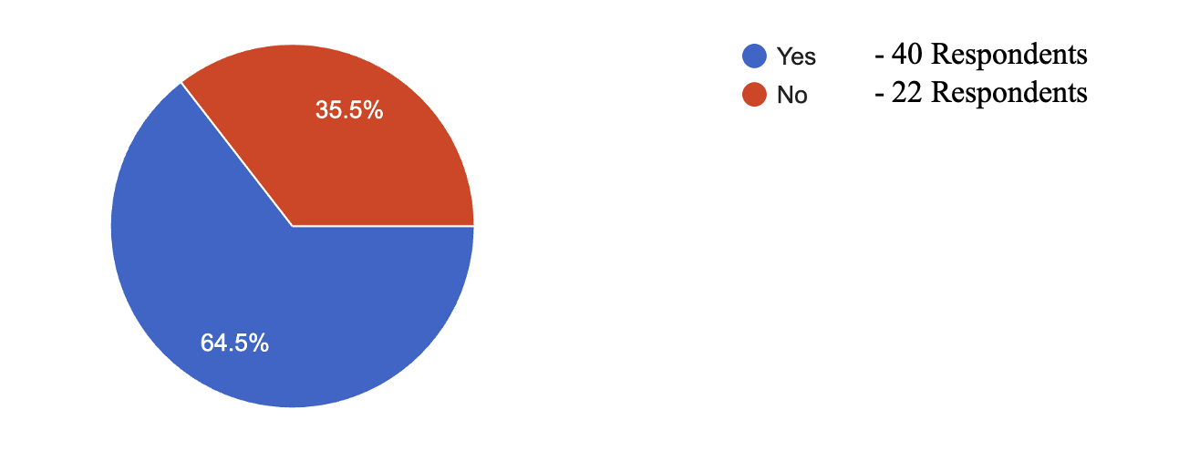
When people were asked if they have ever bought clothes or accessories after seeing them on Instagram, 64.5% said "yes". This shows that Instagram has a big influence on what people buy. On the other hand, 35.5% said "no", which means not everyone buys things after seeing them on Instagram.
FREQUENCY OF PURCHASE
How often do you purchase fast fashion items?
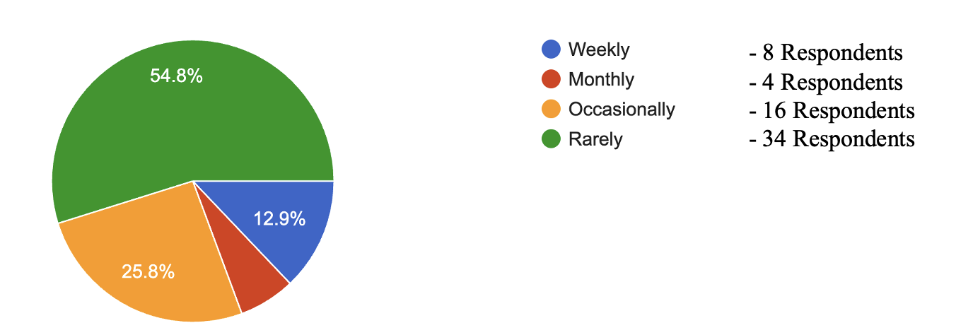
When people were asked how often they buy fast fashion items, 12.9% said they buy every week. Some people said they buy once a month, and 25.8% said they buy occasionally. Most people, about 54.8%, said they rarely buy fast fashion clothes.
INFLUENCE OF INSTAGRAM ON FOLLOWING FASHION TRENDS
Does Instagram encourage you to keep up with the latest fashion trends?
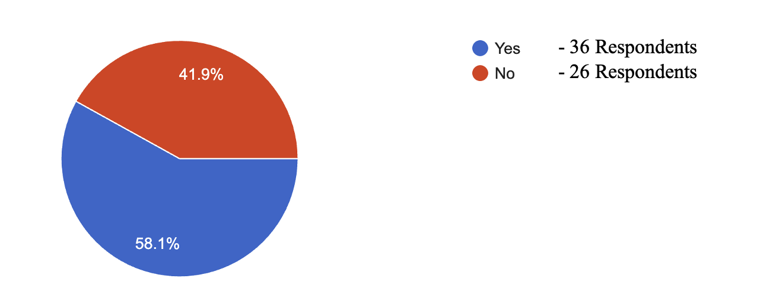
When people were asked if Instagram encourages them to follow the latest fashion trends, 41.9% said "yes". This means many people get inspired by fashion on Instagram. But 58.1% said "no", which shows that more than half of the people are not influenced by fashion trends on the app.
PERCEIVED SOCIAL PRESSURE TO DRESS FASHIONABLY
Do you feel the pressure to dress fashionably because of what you see on Instagram?
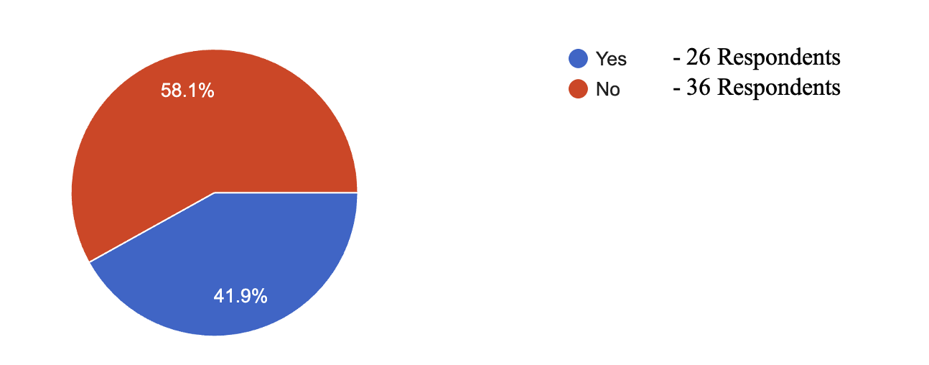
In this survey, 58.1% responded "No", meaning most people do not feel pressure from Instagram to dress in a certain way. However, 41.9% said "Yes", which shows that some people do feel influenced by the fashion they see on the platform. This result tells us that while Instagram can impact fashion choices, many still feel confident dressing in their own way without pressure.
IMPACT OF INSTAGRAM ON FASHION PERCEPTION
In your opinion, has Instagram changed the way you think about fashion?
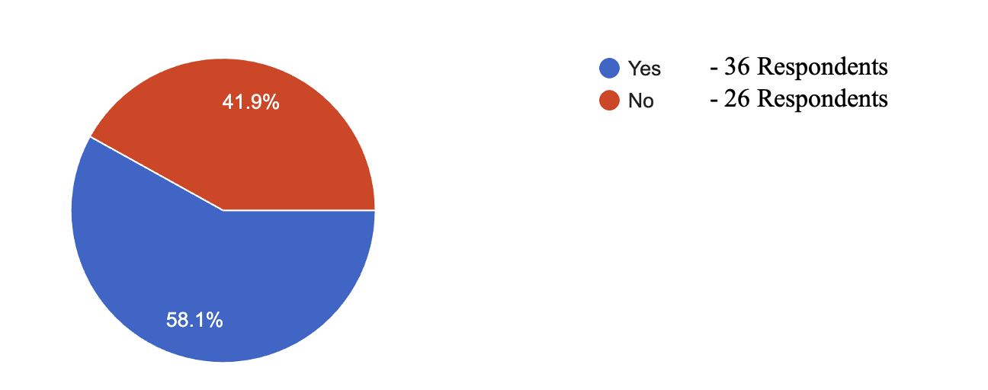
According to the responses 58.1% said "Yes"—they feel that Instagram has changed their view of fashion. They may get new ideas, follow trends, or explore different styles because of what they see on the platform. On the other hand, 41.9% said "No", meaning Instagram has not made much difference in how they think about fashion. This shows that for many people, Instagram plays a role in shaping fashion ideas, but not for everyone.
ROLE OF INFLUENCERS IN PURCHASE DECISIONS
Was there a specific time when an Instagram post or influencer influenced your fashion purchase?
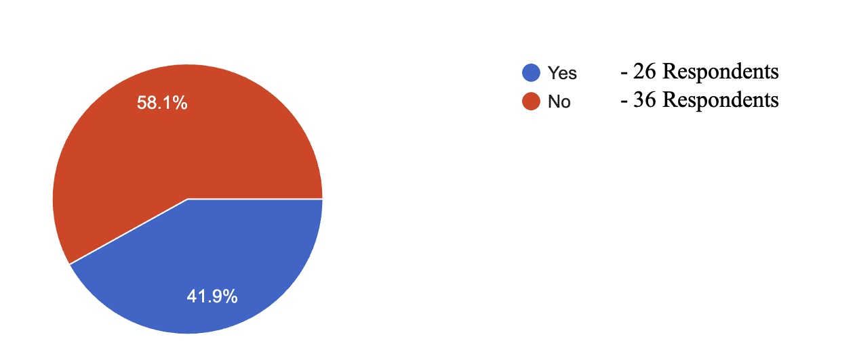
In this survey, 41.9% said "Yes", meaning that they were influenced by a specific Instagram post or influencer to buy something related to fashion. However, 58.1% said "No", showing that more than half of the people have not made a fashion purchase because of Instagram content. This result shows that while influencers and posts do affect some people’s shopping decisions, the majority are still not directly influenced by them.
APPEAL OF FAST FASHION ADVERTISING ON INSTAGRAM
Do you find fast fashion advertising on Instagram to be appealing?
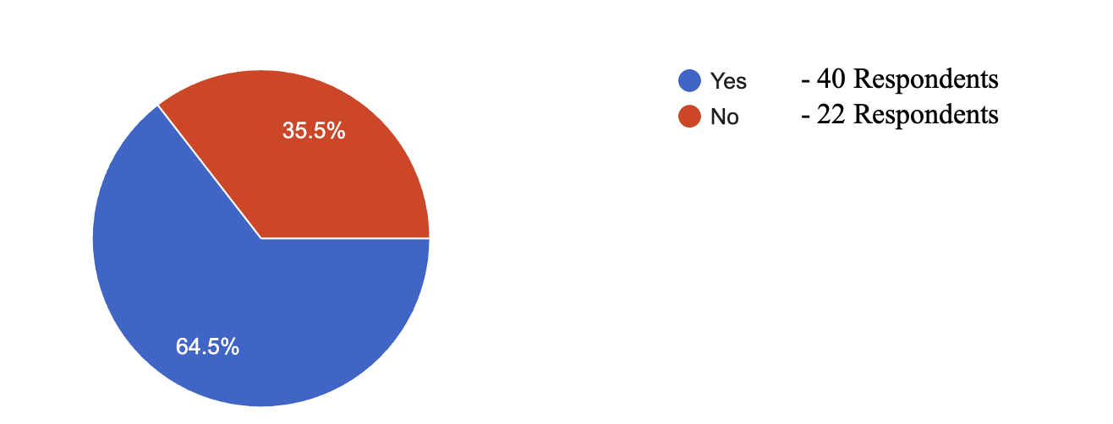
In response, 64.5% said "Yes", which means they like and find fast fashion ads attractive on Instagram. These ads may catch their attention, look trendy, or seem affordable. On the other hand, 35.5% said "No", meaning they don’t find such ads appealing. This shows that most people enjoy seeing fast fashion ads on Instagram, but a good number still don’t get influenced by the ads.
CONSUMPTION FOR SOCIAL DISPLAY

Have you ever felt influenced to buy something on Instagram just to show it off?
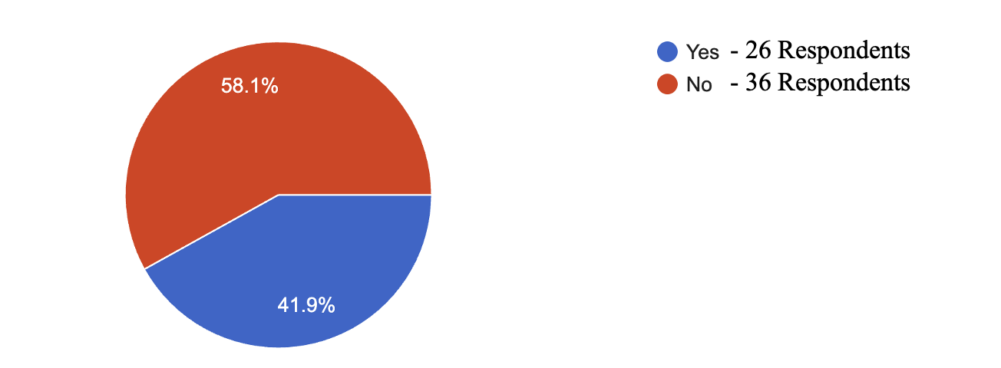
41.9% said "Yes", meaning they bought something from Instagram mainly to show others. This could be clothes, accessories, or anything that looks trendy online. But 58.1% said "No", meaning they don’t buy things just to show off on Instagram. This tells us that while many people are influenced by what they see online, most still buy things for themselves and not just for social media appearance.
INFLUENCE ON CLOTHING CONSUMPTION BEHAVIOR
Do you think that Instagram increases the amount of clothing you buy?
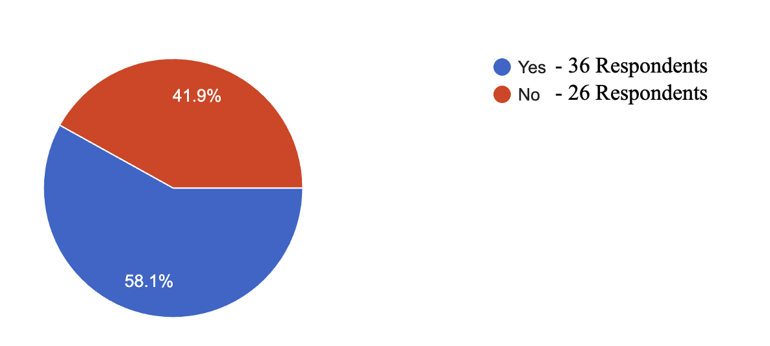
58.1% said "Yes" – They feel that Instagram makes them buy more clothes. This could be because of fashion posts, influencer content, or ads that look attractive and trendy.41.9% said "No" – These people feel Instagram doesn’t affect how much clothing they buy. So, more than half of the people agree that Instagram influences their shopping habits, especially for clothes.
IMPACT ON BODY IMAGE AND SELF-ESTEEM
Has Instagram changed the way you think about your body image or self-esteem?
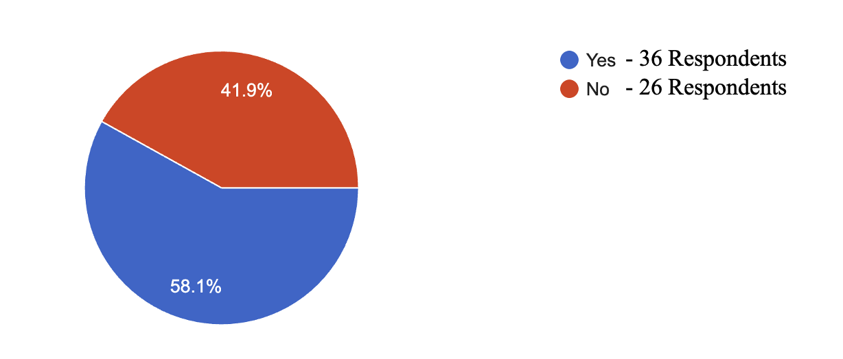
58.1% of respondents stated that Instagram has influenced the way they perceive their body image or self-esteem, indicating that most users are affected by the content they see on the platform. But 41.9% said it has not affected them.
POST-PURCHASE REGRET AND CONSUMER SATISFACTION
Have you ever regretted a fashion purchase you made after seeing it on Instagram?
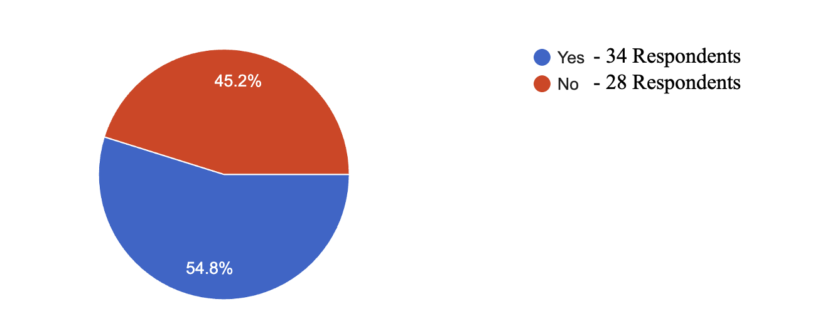
54.8% of respondents reported that they regretted a fashion purchase influenced by Instagram, indicating that more than half of the participants experienced some level of dissatisfaction after buying a product they saw on the platform. On the other hand, 45.2% of respondents stated that they did not regret their purchases,
MONTHLY EXPENDITURE ON INSTAGRAM-DRIVEN FASHION SHOPPING
On an average, how much do you pay every month on fashion shopping from Instagram?
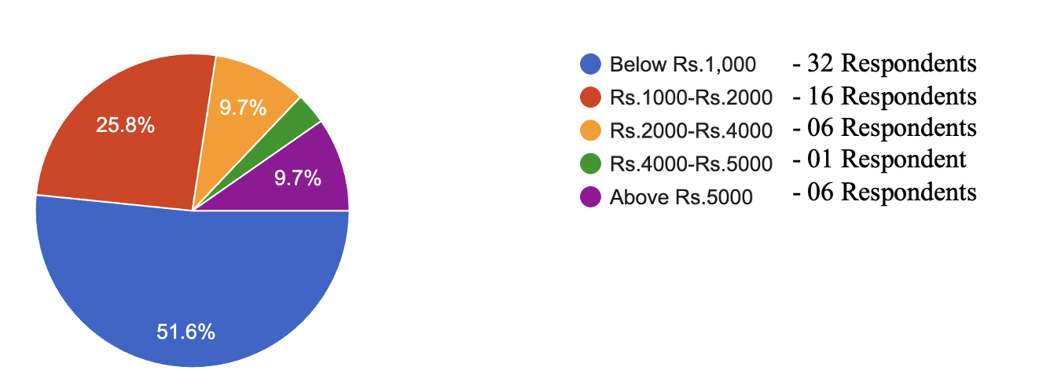
Most of them said they keep their spending low. Half of the respondents spend less than ₹1,000 every month. Around 19% of them spend between ₹1,000 to ₹2,000, and the same number of people spend between ₹2,000 to ₹4,000. Only one person spends between ₹4,000 to ₹5,000. A small group, about 9%, spends more than ₹5,000 monthly. This shows that while Instagram does influence shopping, most users still prefer to shop on a budget.
Key Findings
- High Instagram Engagement:
A significant portion of users (29%) spend more than 4 hours daily on Instagram, indicating high platform engagement. Another large group (32.3%) spends 1-2 hours daily, further solidifying Instagram's role as a major time sink for many.
- Strong Influence on Fashion Purchases:
A considerable majority (64.5%) of respondents have made clothing or accessory purchases after seeing them on Instagram, highlighting the platform's direct impact on consumer buying behavior. Fast fashion advertising is perceived as appealing by most (64.5%), contributing to the platform's purchasing influence. Over half (58.1%) of users believe Instagram increases the amount of clothing they buy.
- Mixed Impact on Fashion Trends and Personal Style:
While 41.9% feel Instagram encourages them to keep up with the latest fashion trends, a larger 58.1% are not influenced, suggesting that trend adoption is not universal. Similarly, the majority (58.1%) do not feel pressured to dress fashionably due to Instagram, indicating a degree of individuality persists despite platform exposure.
- Fast Fashion Habits Lean Towards Moderation:
Majority of respondents (54.8%) rarely purchase fast fashion items, with only a small percentage (12.9%) buying them weekly, suggesting a general preference for less frequent fast fashion consumption.
- Instagram's Impact on Self-Perception is Notable:
A significant 58.1% reported that Instagram has changed how they feel about their body image or self-esteem, pointing to a potential psychological impact of the platform's curated visuals.
- Purchase Regret is Common:
More than half (54.8%) of users regretted a fashion purchase they made after seeing it on Instagram, indicating a disconnect between online appearance and real-world satisfaction.
- Budget-Conscious Fashion Spending:
Despite Instagram's influence, half of the respondents spend less than ₹1,000 monthly on fashion shopping from the platform, indicating that most users maintain a budget-conscious approach to online fashion purchases.
Conclusion
The survey findings reveal Instagram's significant, yet complex, role in shaping fashion consumption habits and perceptions among users. While a substantial portion of the surveyed population (over 29%) spends more than 4 hours daily on the platform, indicating high engagement, their interaction with fashion content and its impact varies.
A key takeaway is Instagram's demonstrable influence on purchasing decisions, with 64.5% of respondents admitting to buying clothing or accessories after seeing them on the platform. This is further supported by the appealing nature of fast fashion advertising, as reported by 64.5% of users. Moreover, a majority (58.1%) acknowledge that Instagram increases their clothing purchases, and a notable 41.9% have been directly influenced by a specific post or influencer for a fashion purchase. However, this influence isn't universal, as a significant 58.1% have not made a fashion purchase due to Instagram content.
Despite the evident purchasing influence, the relationship with fashion trends and self-perception is more nuanced. While 41.9% feel Instagram encourages them to keep up with trends, a larger portion (58.1%) remains uninfluenced. Similarly, a majority (58.1%) do not feel pressure to dress fashionably because of Instagram, suggesting a degree of resilience against perceived social pressures. Nevertheless, a concerning 58.1% reported that Instagram has changed their body image or self-esteem, highlighting a potential negative psychological impact of the platform's visual nature. Furthermore, a slight majority (54.8%) have regretted a fashion purchase made after seeing it on Instagram, indicating that visual appeal on the platform doesn't always translate to long-term satisfaction.
Regarding fast fashion, while 12.9% buy items weekly, the vast majority (54.8%) rarely purchase fast fashion, suggesting a broader consumer base that may not be heavily invested in rapid trend cycles despite Instagram's influence. Financial data also indicates a budget-conscious approach, with half of the respondents spending less than ₹1,000 monthly on Instagram-influenced fashion, reinforcing that while Instagram drives purchases, it often does so within financial constraints for most users.
In summary, Instagram serves as a powerful discovery and purchasing channel for fashion, with a clear ability to drive sales and alter shopping habits for many. However, its influence on adopting trends, perceived social pressure, and self-esteem is less definitive and more varied among users. The platform's impact is multifaceted, fostering both inspiration and potential regret, while largely accommodating budget-conscious spending on fashion items.
This study titled “The Influence of Instagram on Fast Fashion Consumption Among Youth” reveals that Instagram plays a pivotal role in shaping the fashion preferences, purchasing behavior, and self-perception of young consumers. A significant portion of respondents admitted to being influenced by fashion-related content, advertisements, and influencers on the platform. Instagram not only drives increased interest in the latest trends but also contributes to higher levels of consumption and occasional regret over impulsive purchases. While it offers fast fashion brands a powerful channel for engagement and promotion, the findings also highlight the importance of fostering digital literacy and responsible consumer behavior among youth.
References
Bonilla-Quijada, María & Olmo-Arriaga, Josep & Andreu, David & Ripoll-i-Alcon, Joan. (2024). Fast fashion consumer engagement on Instagram: a case study. Cogent Business & Management. 11. https://doi.org/10.1080/23311975.2024.2322111
Djafarova, E., & Rushworth, C. (2017). Exploring the credibility of online celebrities' Instagram profiles in influencing the purchase decisions of young female users. Computers in Human Behavior, 68, 1–7. https://doi.org/10.1016/j.chb.2016.11.009
Joy, A., Sherry, J. F., Venkatesh, A., Wang, J., & Chan, R. (2012). Fast fashion, sustainability, and the ethical appeal of luxury brands. Fashion Theory, 16(3), 273–295. https://doi.org/10.2752/175174112X13340749707123
Kaplan, A. M., & Haenlein, M. (2010). Users of the world, unite! The challenges and opportunities of social media. Business Horizons, 53(1), 59–68. https://doi.org/10.1016/j.bushor.2009.09.003
Martinicorena-Goñi, Naiara & Aramendia-Muneta, Maria Elena. (2023). Instagram's Marketing Strategy of the Main Fast Fashion Brands: Best Practices to Improve Customer Engagement. https://doi.org/10.4018/978-1-6684-8753-2.ch008
Phua, J., Jin, S. V., & Kim, J. (2017). Uses and gratifications of social media: A comparison of Facebook and Instagram. Computers in Human Behavior, 72, 115–122. https://doi.org/10.1016/j.chb.2017.02.041
Tiggemann, M., & Zaccardo, M. (2015). “Exercise to be fit, not skinny”: The effect of fitspiration imagery on women's body image. Body Image, 15, 61–67. https://doi.org/10.1016/j.bodyim.2015.06.003

