Digital Influence, Consumer Trust, and Sustainable Market Growth:
Implications for India's Viksit Bharat 2047
Author
Ankita Kakaty¹
¹PhD Research Scholar, Department of Business Administration, Gauhati University, Guwahati, Assam, India
E-mail: ankitakakaty@gmail.com.
Contact Number: +917002188374

Second Author
Dr. Samir Sarkar²
²Assistant Professor and Research Supervisor,
Department of Business Administration, Gauhati University, Guwahati, Assam, India

Abstract
India's Vision 2047 blueprint positions digital transformation, inclusive innovation, and sustainable economic development as the cornerstones of its centenary developmental aspirations. Against this backdrop, the rapid expansion of digital infrastructure — with approximately 820 million internet users and 467 million active social media users (IAMAI & Kantar, 2023; Statista, 2023) — has fundamentally reshaped consumer engagement dynamics, particularly in lifestyle product markets. India's influencer marketing industry, currently valued at over Rs. 2,200 crore and expanding at an estimated 25-30 per cent annually (Statista, 2023), has emerged as a strategically significant channel for brand communication, market access, and enterprise visibility.
This paper examines the interrelationship between digital influence, consumer trust, and sustainable market growth within the lifestyle product segment of Assam, a regional economy undergoing a meaningful structural transition toward sustainability-oriented enterprise development. Employing a secondary research design, the study synthesises peer-reviewed empirical literature, industry statistical reports, and regional policy documents through systematic thematic content analysis. A Systematic Literature Matrix (SLM) comprising twelve foundational studies is presented to map the theoretical and empirical landscape rigorously.
The findings demonstrate that influencer credibility — operationalised across the dimensions of trustworthiness, expertise, and authenticity — functions as a primary antecedent of consumer trust, which in turn positively influences purchase intention and sustained brand engagement. The paper further argues that influencer-driven digital ecosystems serve as cost-effective promotional pathways for MSMEs, reducing structural market barriers and extending geographic reach. When anchored in sustainable business practices, such digital trust mechanisms can actively contribute to resilient, inclusive, and value-chain-anchored regional economic growth aligned with India's Vision 2047 objectives.
Keywords: Digital influence, consumer trust, sustainable market growth, influencer credibility, MSMEs, Vision 2047, Assam, social media marketing

1. Introduction
India's long-term developmental vision — Viksit Bharat 2047 — is anchored in the ambition of becoming a fully developed economy by the centenary of its independence. Central to this vision are the twin enablers of digital transformation and sustainable enterprise growth, both of which are increasingly mediated through digital ecosystems that have transformed how consumers discover, evaluate, and purchase products (Government of India, 2023; NITI Aayog, 2022). In this context, social media influencers have emerged not merely as marketing instruments but as structural intermediaries in regional economic development, shaping consumer perceptions and enabling market access for enterprises that would otherwise lack promotional reach.
The scale of India's digital adoption is significant. With approximately 820 million internet users — representing nearly 59 per cent of the population — and over 467 million active social media users (IAMAI & Kantar, 2023; Statista, 2023), the country's digital consumer base is among the world's largest. Mobile connectivity has played a decisive role in this expansion, with close to 700 million smartphone users enabling content consumption across diverse geographic and socio-economic tiers (IBEF, 2023). Lifestyle product categories — spanning handloom textiles, eco-crafts, beauty, wellness, and organic food — have proved especially amenable to influencer-mediated promotion, given their high visual and experiential value.
Assam presents a particularly instructive regional case. Conventionally dependent on tea, handloom, and natural resource sectors, the state is undergoing a meaningful structural transition toward sustainability-oriented enterprise models. Recent developments underscore this momentum. Esah Tea's microplastic-free organic cultivation practices have aligned traditional tea production with contemporary environmental standards (Government of Assam, 2024). The Assam Pani Meteka Craft, awarded GI recognition in 2024, has converted the invasive water hyacinth into a platform for eco-friendly handicrafts and rural employment generation (Geographical Indications Registry of India, 2024). At the infrastructural level, Assam's first Aqua Tech Park in Sonapur and the strategic consultations under Advantage Assam 2.0 and Viksit Assam 2047 reflect institutional commitment to technology-enabled growth (Department of Industries & Commerce, Assam, 2024).
Despite the growing visibility of sustainable enterprise initiatives in Assam, the mechanisms through which digital influence contributes to consumer trust formation and long-term market development in regional economies remain insufficiently examined. The present paper addresses this gap by examining, through a systematic secondary analysis, how influencer credibility shapes consumer trust and purchase intention within Assam's lifestyle product market, and how these dynamics may contribute to sustainable, inclusive economic development consistent with India's Vision 2047 objectives.

2. Conceptual and Theoretical Foundation
2.1 Digital Reconfiguration of Market Structures
The past decade has witnessed a fundamental reorganisation of market communication structures, driven by the exponential growth of social media platforms. Traditional top-down, brand-to-consumer messaging architectures have given way to decentralised, network-based interaction models in which individuals — influencers, content creators, or opinion leaders — exercise significant persuasive authority within digitally mediated communities (Kaplan & Haenlein, 2010; De Veirman et al., 2017). The expansion of mobile connectivity has accelerated this transformation most markedly within lifestyle product categories, where influencers increasingly participate in the full arc of the consumer journey — from initial product discovery through post-purchase community engagement.
2.2 Source Credibility Theory and Digital Persuasion
Hovland and Weiss (1951) established that the perceived credibility of a communicator — understood through dimensions of trustworthiness and expertise — substantially determines the effectiveness of persuasive messages. In digital contexts, credibility is constructed through consistent content specialisation, transparent disclosure practices, and the perception of authentic self-presentation (Lou & Yuan, 2019; Ohanian, 1990). Together, trustworthiness, expertise, and authenticity build the persuasive capital necessary for effective consumer communication. In digital marketplaces characterised by information saturation, credibility becomes especially critical in enabling trust formation and purchase intention.
2.3 Elaboration Likelihood Model and Consumer Processing
The Elaboration Likelihood Model (ELM) provides a complementary lens for understanding how consumers process influencer-mediated persuasion (Petty & Cacioppo, 1986). The model proposes that persuasive messages are processed through either a central route — characterised by high cognitive engagement with message arguments — or a peripheral route, where attitude change is triggered by contextual cues. In influencer marketing practice, detailed product demonstrations stimulate central-route processing, fostering durable attitude change, while aesthetic cues, social proof indicators, and aspirational lifestyle imagery function as peripheral signals. Figure 2 illustrates this dual-route model as applied to the influencer marketing context.
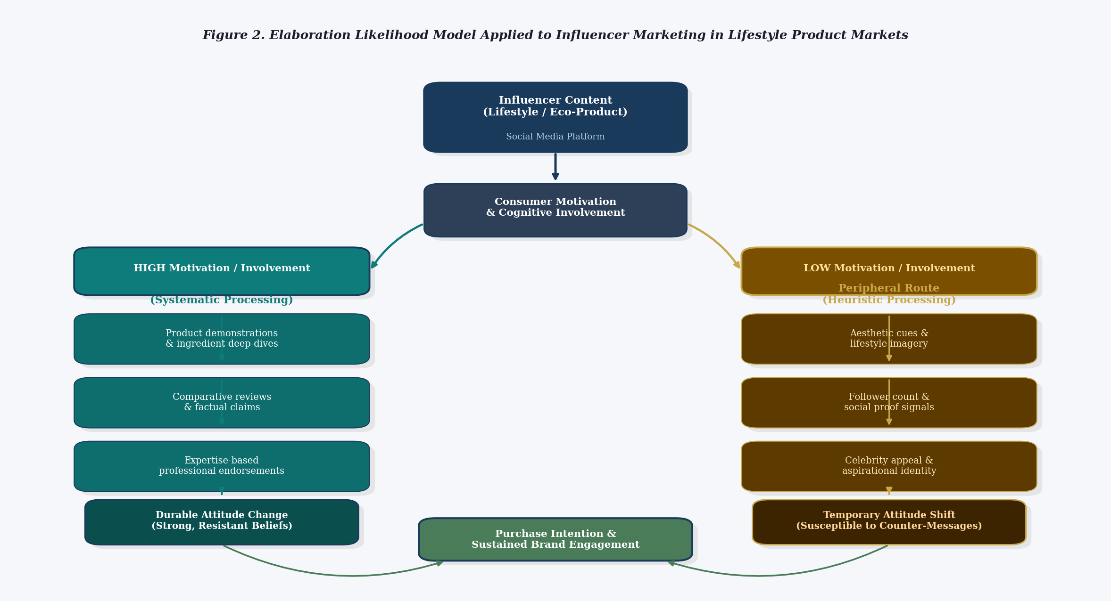
Figure 2. Elaboration Likelihood Model Applied to Influencer Marketing in Lifestyle Product Markets
2.4 Trust Formation in Digital Marketplaces
Trust is broadly recognised as a cornerstone of online consumer behaviour (Sheth & Parvatiyar, 1995). In digital contexts, trust functions as a mechanism that reduces perceived risk, enhances decision confidence, and strengthens behavioural intentions including purchase, repeat engagement, and brand advocacy (Ajzen, 1991). In regional markets such as Assam, where digital commerce is expanding alongside traditional retail structures, influencers who share linguistic, cultural, or geographic affiliation with their audiences may exhibit stronger trust-building capacity, given the perceived proximity and shared context.
2.5 Sustainability, Market Resilience, and Triple-Bottom-Line Accountability
Sustainable market growth extends well beyond short-term transactional success. It encompasses the stability of demand cycles, the durability of consumer relationships, the ethical integrity of communication practices, and the inclusive participation of diverse stakeholders in economic systems (Elkington, 1997; Belz & Peattie, 2012). In Assam, enterprises integrating environmental accountability into their business models — GI-certified eco-crafts, organic agricultural ventures — represent exactly this orientation. When these sustainability-oriented enterprises leverage influencer-driven digital promotion, the potential exists not only to expand market access, but also to reinforce consumer awareness of ethical consumption, contributing to the resilience of local value chains.

3. Methodology
This study employs a qualitative secondary research design, drawing upon peer-reviewed empirical literature, industry statistical reports, and regional policy documents as primary data sources. Relevant studies were identified through systematic database searches across Google Scholar, Scopus, and Web of Science using the key terms: digital influence, influencer marketing, consumer trust, purchase intention, MSMEs, social media marketing, sustainable market growth, and regional digital ecosystems. Studies published between 1990 and 2024 were considered, with emphasis on peer-reviewed journal articles, foundational theoretical works, and recent industry reports.
A total of twelve studies were selected for inclusion in the Systematic Literature Matrix (SLM) based on their theoretical significance, methodological robustness, and direct relevance to the study's conceptual framework. Thematic content analysis was applied to identify recurring patterns concerning influencer credibility dimensions, mechanisms of consumer trust formation, and pathways linking digital engagement to sustainable market outcomes. Quantitative data from industry and government reports were compiled into summary matrices to contextualise the Indian and Assam-specific digital ecosystem.

4. India's Digital Ecosystem: A Quantitative Overview
To contextualise the study's arguments, Table 1 presents a quantitative summary of key indicators characterising India's digital consumer ecosystem. These statistics, drawn from authoritative industry and government sources, illustrate the scale and growth trajectory of digital engagement that makes influencer marketing an increasingly consequential channel for brand communication and market development.
Table 1. Quantitative Indicators: India's Digital Consumer Ecosystem
Indicator | Value / Volume | Context | Source
Internet users in India | ~820 million | ~59% population penetration | IAMAI & Kantar (2023)
Active social media users in India | ~467 million | ~33% population reach | Statista (2023)
India influencer marketing industry size | Rs. 2,200 crore (~USD 265 mn) | ~25-30% YoY growth | Statista (2023)
India smartphone users | ~700 million | Highest globally by volume | IBEF (2023)
Assam internet users (estimated) | ~15-18 million | Based on ~40% rural penetration | TRAI (2023, est.)
MSME share in India's GDP | ~30% | ~6 crore registered MSMEs | Ministry of MSME (2023)
Digital payments growth (India) | +76% YoY (UPI) | 10 billion transactions/month | NPCI (2023)
Instagram influencer engagement rate (India) | ~3.86% | vs. global avg. of 1.94% | Influencer Marketing Hub (2023)
Note. Data compiled from IAMAI & Kantar (2023), IBEF (2023), Statista (2023), NPCI (2023), Ministry of MSME (2023), Influencer Marketing Hub (2023), and TRAI (2023). Assam figures are estimated from aggregate national data and state-level internet penetration reports.
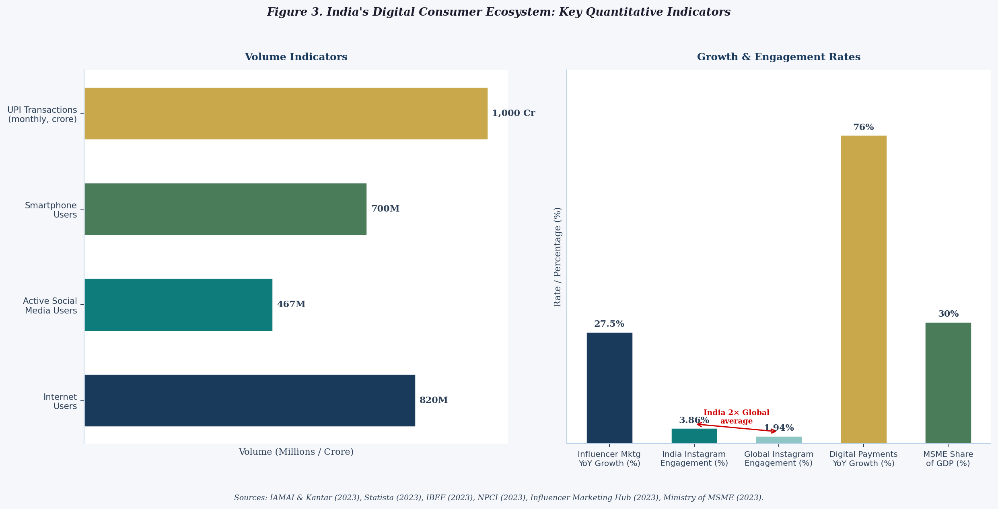
Figure 3. India's Digital Consumer Ecosystem: Key Quantitative Indicators
Several observations are particularly relevant to the study's central arguments. India's Instagram engagement rate of approximately 3.86 per cent — nearly double the global average of 1.94 per cent (Influencer Marketing Hub, 2023) — suggests that Indian consumers are meaningfully interactive with influencer content. This elevated engagement level reinforces the persuasive and trust-building potential of influencer communication. Additionally, the 76 per cent year-on-year growth in UPI transactions (NPCI, 2023) signals the structural maturation of India's digital payment infrastructure, thereby lowering barriers to influencer-driven online commerce even in Tier-II and Tier-III markets.

5. Systematic Literature Matrix
The Systematic Literature Matrix (Table 2) presents a structured synthesis of twelve foundational and empirical studies that inform the paper's conceptual framework. The matrix maps each study along five analytical dimensions: study context, methodology, key finding, and its specific relevance to the present investigation, enabling a transparent and replicable audit of the theoretical and empirical foundations upon which the paper's arguments are built.
Table 2. Systematic Literature Matrix: Digital Influence, Consumer Trust, and Sustainable Market Development
Author(s) & Year | Study Context | Method | Key Finding | Relevance to Present Study
Hovland & Weiss (1951) | Source credibility in mass communication | Experimental | Communicator trustworthiness and expertise significantly enhance message acceptance | Foundational basis for influencer credibility as a trust antecedent
Petty & Cacioppo (1986) | Persuasion processing in varied motivation contexts | ELM meta-analysis | Dual-route processing (central vs. peripheral) determines attitude change depth | Explains how product demonstrations vs. lifestyle imagery drive purchase intent differently
Ajzen (1991) | Intention-behaviour linkage in consumer decisions | Survey / TPB | Attitudes, subjective norms, and perceived control predict behavioural intention | Grounds trust-to-purchase-intention pathway in the framework
Sheth & Parvatiyar (1995) | Relationship marketing in consumer markets | Conceptual / Review | Long-term relational commitment underpins sustainable consumer-brand bonds | Supports the claim that trust enables market resilience beyond one-time transactions
Elkington (1997) | Triple-bottom-line sustainability in business | Conceptual | Sustainable growth requires simultaneous economic, social, and environmental accountability | Defines the sustainability lens through which influencer-driven market growth is evaluated
Kaplan & Haenlein (2010) | Social media typology and business implications | Conceptual / Review | Social media reshapes brand communication from one-to-many to networked models | Contextualises the shift from traditional advertising to influencer-mediated promotion
Freberg et al. (2011) | Public perceptions of social media influencers | Survey (USA) | Influencers perceived as independent opinion leaders shaping beliefs and behaviour | Establishes intermediary role of influencers between brands and consumers
De Veirman et al. (2017) | Instagram influencer follower count and brand attitude | Experimental (Belgium) | High follower counts raise awareness; divergent product fit reduces brand attitude | Highlights the importance of product-influencer congruence for trust formation
Chaffey & Ellis-Chadwick (2019) | Digital marketing adoption in SMEs | Review / Case study | Cost-effective social media channels expand SME market reach significantly | Supports the MSME-influencer synergy argument in regional economic contexts
Lou & Yuan (2019) | Branded content credibility on social media | Survey (USA) | Message value and influencer credibility positively affect consumer trust and purchase intention | Directly informs the credibility-trust-purchase intention pathway of the framework
Sokolova & Kefi (2020) | Parasocial interaction and purchase intent on Instagram/YouTube | Survey (France) | Credibility and parasocial bonding drive purchase intentions; disclosure matters | Validates authenticity and transparency as key moderators of influencer effectiveness
Taiminen & Karjaluoto (2015) | Digital marketing channel usage in SMEs | Survey (Finland) | SMEs underutilise digital channels despite high potential; awareness and skills are barriers | Motivates the need for digital capacity-building among Assam's MSMEs
Note. Studies selected based on theoretical significance, methodological rigour, and relevance to the study's research objectives. ELM = Elaboration Likelihood Model; TPB = Theory of Planned Behaviour.
A careful reading of the SLM reveals three convergent thematic findings. First, there is strong and consistent empirical support for the positive relationship between influencer credibility and consumer trust across diverse cultural and market contexts (Hovland & Weiss, 1951; Lou & Yuan, 2019; Sokolova & Kefi, 2020). Second, the ELM framework and Theory of Planned Behaviour together explain why trust translates into durable purchase intentions (Petty & Cacioppo, 1986; Ajzen, 1991). Third, digital marketing channels offer demonstrable advantages for SMEs in terms of market reach and promotional cost-efficiency, though structural and capacity barriers persist (Taiminen & Karjaluoto, 2015).

6. Review of Empirical Literature
6.1 Influencer Credibility and Trust Construction
The positive relationship between influencer credibility and consumer trust is among the most consistently replicated findings in digital marketing research (De Veirman et al., 2017; Lou & Yuan, 2019). Across experimental and survey-based studies, perceived expertise, trustworthiness, and authenticity together explain a meaningful portion of variance in consumer trust toward influencer recommendations. Sokolova and Kefi (2020) extended this understanding by demonstrating that parasocial bonding amplifies credibility effects, while transparent disclosure of commercial relationships moderates them positively. Authenticity has emerged as a decisive moderating variable: consumers exhibit heightened trust when the product category aligns with the influencer's established content domain (De Veirman et al., 2017).
6.2 Trust, Purchase Intention, and Behavioural Outcomes
Consumer trust consistently mediates the relationship between influencer credibility and purchase intention across diverse behavioural models (Ajzen, 1991; Lou & Yuan, 2019). Both the ELM and the Theory of Planned Behaviour predict that trust reduces perceived risk, thereby lowering the cognitive barrier to purchase decisions. Empirical evidence confirms that trust generated through influencer communication not only increases initial purchase intention but also strengthens repeat purchasing behaviour and brand loyalty over time (Sokolova & Kefi, 2020). In the Indian context, the growing dependence of consumers in Tier-II and Tier-III cities on social media for product discovery makes trust particularly consequential in markets such as Assam.
6.3 Influencer Marketing and MSME Growth
Secondary studies on digital marketing adoption by MSMEs consistently demonstrate that social media-based promotional channels offer cost-effective routes to audience reach (Chaffey & Ellis-Chadwick, 2019; Taiminen & Karjaluoto, 2015). For MSMEs in Assam operating within eco-craft, handloom textile, and organic agricultural segments, influencer-mediated digital promotion offers geographic reach beyond regional boundaries, enabling access to diaspora consumers, ethical lifestyle markets, and sustainability-conscious urban buyers. However, the long-term viability of this growth depends critically on the ethical integrity of influencer communication and the maintenance of trust as a foundational currency in digital consumer relationships.
6.4 Digital Ecosystems and Sustainable Development Pathways
The sustainable development literature emphasises the interconnection between economic growth, environmental responsibility, and social inclusion as the foundational elements of resilient economies (Elkington, 1997; Belz & Peattie, 2012). When digital ecosystems are designed around transparency and trust, they can actively support responsible consumption patterns and strengthen value chain sustainability. In Assam, the convergence of GI-certified eco-craft recognition, organic enterprise development, and sustainability-oriented infrastructure investment signals regional commitment to the innovation-led, inclusive growth that India's Vision 2047 framework envisions nationally.

7. Research Gaps and Analytical Imperatives
Notwithstanding the growing body of literature on influencer marketing and digital consumer behaviour, a series of significant analytical gaps remain. First, there is a pronounced geographic bias toward metropolitan markets in the United States, Europe, and Indian urban centres, leaving the consumer dynamics of emerging regional economies such as Assam largely unexamined. Second, the prevailing literature is characterised by a short-term outcome bias, measuring immediate behavioural responses while long-term market resilience mechanisms remain empirically underexplored. Third, despite the demonstrable role of digital marketing in MSME growth, the specific pathways through which influencer ecosystems strengthen regional enterprise competitiveness have not been adequately modelled. Fourth, existing scholarship rarely integrates digital consumer behaviour research with national development frameworks such as Vision 2047 (Government of India, 2023). Fifth, and most fundamentally, there is a conspicuous absence of unified frameworks integrating digital influence, consumer trust, and sustainability metrics applicable to regional Indian markets.

8. Conceptual Framework and Research Hypotheses
Drawing upon Source Credibility Theory (Hovland & Weiss, 1951), the Elaboration Likelihood Model (Petty & Cacioppo, 1986), the Theory of Planned Behaviour (Ajzen, 1991), and the trust-based consumer behaviour literature (Lou & Yuan, 2019; Sokolova & Kefi, 2020), the present study proposes a conceptual framework linking digital influence to sustainable market performance through the mediating construct of consumer trust. The framework positions influencer credibility — operationalised across trustworthiness, expertise, and authenticity (Ohanian, 1990) — as the primary antecedent of consumer trust, which reduces risk perception and strengthens purchase intention within lifestyle markets.
The full structural framework is illustrated in Figure 1 below.
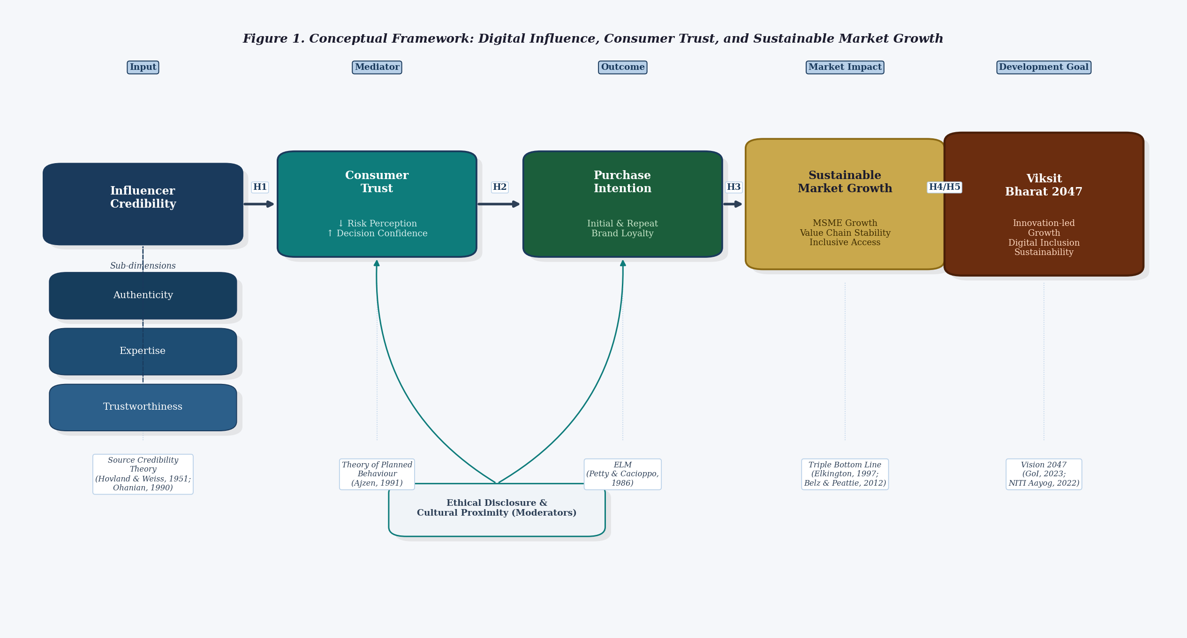
Figure 1. Conceptual Framework: Digital Influence, Consumer Trust, and Sustainable Market Growth
Sustained purchase intention, reinforced through repeated influencer-consumer engagement, is posited to generate stable market demand supporting MSME growth and value chain sustainability. These dynamics are argued to contribute to inclusive and resilient economic development aligned with Vision 2047 objectives — provided that influencer communication remains anchored in ethical disclosure and authentic brand representation.
Table 3. Proposed Research Hypotheses
Hypothesis | Statement
H1 | Influencer credibility (trustworthiness, expertise, authenticity) positively influences consumer trust in lifestyle product recommendations on social media
H2 | Consumer trust positively mediates the relationship between influencer credibility and purchase intention
H3 | Higher purchase intention, sustained through repeated influencer engagement, positively contributes to long-term market resilience for MSMEs
H4 | Influencer-driven digital ecosystems reduce promotional barriers and expand market access for sustainability-oriented MSMEs in regional economies
H5 | Digital trust mechanisms, when aligned with sustainability-oriented enterprise practices, positively support inclusive and resilient economic development consistent with Vision 2047 objectives
Note. Hypotheses H1 and H2 are grounded primarily in Source Credibility Theory and the Theory of Planned Behaviour. H3 extends these to market-level outcomes. H4 draws on the SME digital marketing literature. H5 integrates the sustainability and regional development frameworks.
The hypothesis pathway map (Figure 4) visualises the directional and mediating relationships between constructs, including the moderating roles of ethical disclosure, cultural proximity, and the MSME ecosystem's bidirectional reinforcement of sustainable market growth.
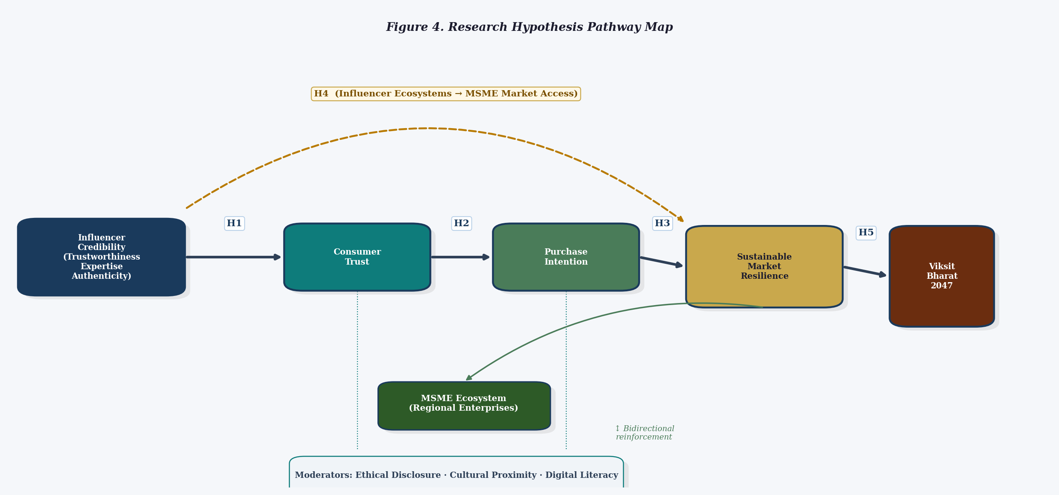
Figure 4. Research Hypothesis Pathway Map (H1-H5)

9. Discussion
The synthesis presented in this study points to a consistent and theoretically grounded account of how digital influence operates in lifestyle product markets and why its effects matter beyond the transactional level. Influencer credibility — built through authentic content specialisation, ethical transparency, and sustained audience engagement — functions as the foundational mechanism through which consumer trust is cultivated in digital environments (Hovland & Weiss, 1951; Lou & Yuan, 2019; Sokolova & Kefi, 2020).
What is particularly notable in the context of Assam's developing digital economy is the compounding effect of cultural and linguistic proximity. Influencers who share regional identity with their audiences are likely to generate trust more effectively than generic national-level creators, because their endorsements carry the implicit credibility of shared lived experience. This has practical implications for how MSMEs in the state approach influencer partnerships: prioritising regional micro-influencers with high audience relevance may produce superior trust outcomes compared to higher-reach national influencers whose cultural alignment with regional consumers is weaker.
The quantitative data presented in Table 1 and Figure 3 reinforces the structural argument for prioritising digital influencer ecosystems as a development enabler. India's exceptionally high Instagram engagement rate (3.86% vs. a global average of 1.94%), combined with the explosive growth of digital payment infrastructure (76% YoY UPI growth), creates conditions under which the conversion of influencer-generated trust into economic transactions is both technically feasible and behaviourally likely at scale.
The study also draws attention to the risks of unsustained trust. Where influencer communication is characterised by undisclosed sponsorships, exaggerated product claims, or incongruent endorsements, the trust constructed can erode rapidly. Regulatory frameworks governing influencer disclosure — such as the Advertising Standards Council of India's guidelines — therefore play an important enabling role in creating conditions for sustainable influencer-driven market development.

10. Scope for Future Research
Several research directions are particularly promising. First, quantitative primary research using structured questionnaires administered to lifestyle product consumers in Assam would enable direct empirical testing of the proposed hypotheses. Structural equation modelling (SEM) would be an appropriate analytical technique for assessing the relative strength of the credibility-trust-purchase intention pathway and the moderating effects of cultural proximity. Second, comparative studies across Tier-I, Tier-II, and Tier-III market contexts would yield important insights into the extent to which the proposed relationships are context-dependent. Third, longitudinal research designs would be valuable in distinguishing durable market-building effects from short-term campaign-driven spikes in purchase intention. Finally, mixed-methods studies combining survey data with qualitative interviews of MSME operators and regional influencers would provide richer understanding of how sustainability-oriented enterprises are deploying influencer marketing as a tool for both commercial growth and sustainability communication.

11. Conclusion
This paper has examined the mechanisms through which digital influence shapes consumer trust and purchase intention in lifestyle product markets, and evaluated the implications for sustainable and inclusive market development in Assam within India's Vision 2047 framework. Drawing on a systematic synthesis of twelve empirical and theoretical studies, supplemented by quantitative data on India's digital ecosystem, the paper has argued that influencer credibility — operationalised through trustworthiness, expertise, and authenticity — functions as the primary driver of consumer trust in digital environments, enabling sustained purchase intentions and resilient brand relationships.
For MSMEs in Assam's sustainability-oriented enterprise sectors, these dynamics hold genuine strategic significance. Influencer-driven digital promotion offers a cost-effective and culturally resonant route to market access, provided that communication practices are grounded in authenticity, ethical disclosure, and meaningful alignment between the influencer's identity and the enterprise's values. The proposed five-hypothesis conceptual framework situates influencer marketing within a developmental discourse that transcends transactional metrics, positioning digital trust as a structural asset for regional economic resilience aligned with Viksit Bharat 2047.

References
Ajzen, I. (1991). The theory of planned behavior. Organizational Behavior and Human Decision Processes, 50(2), 179-211. https://doi.org/10.1016/0749-5978(91)90020-T
Belz, F. M., & Peattie, K. (2012). Sustainability marketing: A global perspective. Wiley.
Chaffey, D., & Ellis-Chadwick, F. (2019). Digital marketing: Strategy, implementation and practice (7th ed.). Pearson.
De Veirman, M., Cauberghe, V., & Hudders, L. (2017). Marketing through Instagram influencers: The impact of number of followers and product divergence on brand attitude. International Journal of Advertising, 36(5), 798-828. https://doi.org/10.1080/02650487.2017.1348035
Department of Industries & Commerce, Assam. (2024). Viksit Assam 2047 consultation document. Government of Assam.
Elkington, J. (1997). Cannibals with forks: The triple bottom line of 21st century business. Capstone.
Freberg, K., Graham, K., McGaughey, K., & Freberg, L. A. (2011). Who are the social media influencers? A study of public perceptions of personality. Public Relations Review, 37(1), 90-92. https://doi.org/10.1016/j.pubrev.2010.11.001
Geographical Indications Registry of India. (2024). GI recognition: Assam Pani Meteka Craft. Government of India.
Government of Assam. (2024). Advantage Assam 2.0 summit report.
Government of India. (2023). Vision India @2047 framework document.
Hovland, C. I., & Weiss, W. (1951). The influence of source credibility on communication effectiveness. Public Opinion Quarterly, 15(4), 635-650. https://doi.org/10.1086/266350
IAMAI & Kantar. (2023). Internet in India report. Internet and Mobile Association of India.
IBEF. (2023). India brand equity foundation digital economy report. Government of India.
Influencer Marketing Hub. (2023). Instagram engagement rate benchmarks by country.
Kaplan, A. M., & Haenlein, M. (2010). Users of the world, unite! The challenges and opportunities of social media. Business Horizons, 53(1), 59-68. https://doi.org/10.1016/j.bushor.2009.09.003
Lou, C., & Yuan, S. (2019). Influencer marketing: How message value and credibility affect consumer trust of branded content on social media. Journal of Interactive Advertising, 19(1), 58-73. https://doi.org/10.1080/15252019.2018.1533501
Ministry of Micro, Small and Medium Enterprises. (2023). Annual report 2022-2023. Government of India.
NITI Aayog. (2022). India's digital economy and innovation strategy. Government of India.
NPCI. (2023). UPI transaction data report. National Payments Corporation of India.
Ohanian, R. (1990). Construction and validation of a scale to measure celebrity endorsers' perceived expertise, trustworthiness, and attractiveness. Journal of Advertising, 19(3), 39-52. https://doi.org/10.1080/00913367.1990.10673191
Petty, R. E., & Cacioppo, J. T. (1986). Communication and persuasion: Central and peripheral routes to attitude change. Springer. https://doi.org/10.1007/978-1-4612-4964-1
Sheth, J. N., & Parvatiyar, A. (1995). Relationship marketing in consumer markets: Antecedents and consequences. Journal of the Academy of Marketing Science, 23(4), 255-271. https://doi.org/10.1177/009207039502300405
Sokolova, K., & Kefi, H. (2020). Instagram and YouTube bloggers promote it, why should I buy? How credibility and parasocial interaction influence purchase intentions. Journal of Retailing and Consumer Services, 53, 101742. https://doi.org/10.1016/j.jretconser.2019.01.011
Statista. (2023). Number of social media users in India: Statistics and insights.
Taiminen, H. M., & Karjaluoto, H. (2015). The usage of digital marketing channels in SMEs. Journal of Small Business and Enterprise Development, 22(4), 633-651. https://doi.org/10.1108/JSBED-05-2013-0073
TRAI. (2023). Telecom subscription data report. Telecom Regulatory Authority of India.

